**NCOPP HOME PAGE**

Colors, typefaces and structural elements need to match the national site.

Top Nav background, accent color, button colors etc: #B6D7A8

Header font: Operetta (serif)

Paragraph font: Montserrat (sans-serif)

Top Nav Categories (headers for future drop-downs). If drop-downs are CSS driven, please leave placeholder code so I (Stefanie) can add drop down menu items as we flesh the site out more if we cannot get the content to you in time before you leave). If they are not CSS driven, please advise type of language used and instructions of how to update the code to add menu items).

Categories in this order: Home, About Us, Projects, Events, Get Involved, Resources, News (aka blog)

**About Us** links to an About page (shell attached. More will be added to this page like a history paragraph, a link to a team page or team list and other items as we go). Under About Us will be a page called **Inspiration. (Inspiration** will link to a gallery type page of photos of homeowners and businesses’ success stories)

**Events** will click into an event calendar whether it be a Google API calendar or similar.

**Get Involved** will link to a contact form which the specifications are in discussion amongst the Communications/Steering teams right now.

Submenu under **Resources**: Native Plant Resources, Pollinator Resources, rethinking turf lawns (will add more as we go) (Each of these items needs a static page created).

News is a better way to say blog – links to a blog

**Center photo hole**: Place attached photo (20230707_180815.jpg) in the full-width photo hole. We will be adding a slider later but for launch one photo at a time is fine.

Main photo shown below

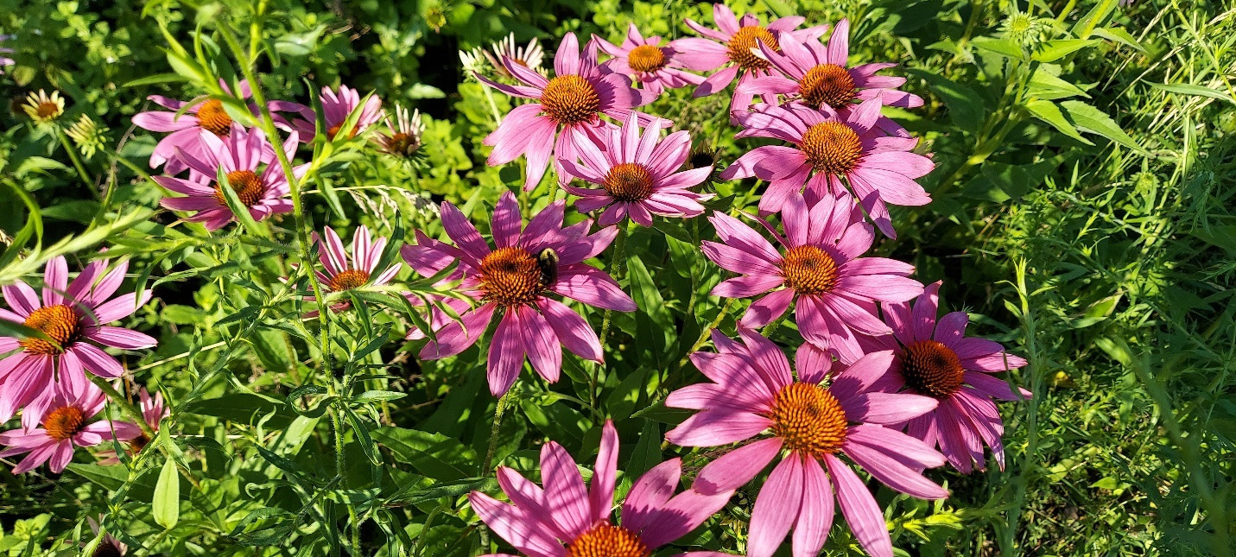

*Alt text for accessibility:* Several pink coneflowers bloom in a suburban garden. The center bloom has a bumble bee busy pollinating it. The flowers are amongst a green carpet of other native plants and flowers. Credit: Stefanie Hauck

All the below elements will have a photo/graphic with text next to it to keep it graphically pleasing, well organized and to break up the text.

Image or art/graphic

HEADER

Text description of event or element here – try to make even with accompanying photo or art in the paragraph font specified on the Home Page document.

The more info button will go here #B6D7A8

*See next page for first sub element.*

*(Place below the main image)*

**Featured Event: Plant For Pollinators!**

Help install a new pollinator habitat with the North Central Ohio Pollinator Pathway at Boardman Arts Park! Learn more about supporting pollinators by planting native plants as we create a new pollinator habitat within the park. For the kids! - Story time at 1 p.m. of *“The Bumblebee Queen”,* by April Pulley Sayre. After planting, head over to Mingo Park for Olentangy Riverfest from noon - 4 p.m. Many thanks to Boardman Arts Park for providing a pollinator habitat site, Natives in Harmony and Leaves for Wildlife for providing the plants, Amy Dutt of Scioto Gardens for the design, and Tyler Frysinger of Strata Eco Solutions for the site preparation. Contact Terry Hermsen for more details at [thermsen@otterbein.edu](mailto:thermsen@otterbein.edu).

(Create a button “Find more events” and link to an “Events” page. A calendar is not needed for launch. We can list events in the photo/text side by side format until a calendar is created and embedded on the site). See attached NCOPP Events Page for content to place on that page for launch. (Art is **Plant-For-Pollinators.jpg**) – place next to text as shown.

*(Place below our featured event of the week/month)*

**Who We Are**

The North Central Ohio Pollinator Pathway is a new chapter of Pollinator Pathways which got its start at a large gathering of like-minded individuals and organizations at Stratford Ecological Center in February 2024. We are committed to engaging and educating communities across the region on how to create and cultivate native habitats of all shapes and sizes to grow climate resilience and boost biodiversity for the benefit of all.

(This will have an image next to it – **Who We Are.jpg**, also attached. Underneath this create a button mirroring the national site titled “Learn more about us” and create a new page called “About” for this to link to.

(Below - not including preview images with blurbs as the above served as examples, please use the .jpgs specified and follow suit with the rest).

*(Place below “Who We Are”)*

**What is a Pollinator Pathway?**

Pollinator pathways are public and private pesticide-free corridors of native plants that provide nutrition and habitat for pollinating insects and birds. Even the smallest green spaces, like flower boxes and curb strips, can be part of a pathway.

(Image to go with this blurb is the **Monarch on a Button Blazing Star.jpg**, attached, please crop to fit without cutting off the butterfly)

(Also no button right now as we have to decide if we are linking to National here or not. You could create a ‘dummy’ button and comment it out with the words “Learn more about Pollinator Pathways”)

*(Place below “What is a Pollinator Pathway”)*

**Why Are Pollinators Important?**

Pollinators are critical to the survival of terrestrial ecosystems worldwide. According to the USDA Forest Service, 80% of crops grown globally rely on pollination by animals and more than 150 food crops in the U.S. depend on pollinators, including almost all fruit and grain crops.

(Image to go with this blurb is the **Large carpenter bee on anise hyssop.jpg**, attached, please crop to fit without cutting off the bee and too much of the flower)

(no button right now as there is no content for this page yet. You could create a ‘dummy’ button and comment it out with the words “Learn more about the importance of pollinators”)

*(Place below “Why are Pollinators Important?”)*

**How can you be a part of the Pollinator Pathway movement?**

Anyone can be a part of the movement because every property owner’s yard and every public space can make a difference. Cultivating native plants and establishing native habitat whether you have acres of land or a few pots on a balcony will help sustain our delicate ecosystem. Contact us for advice, join in on one of our many projects and events or volunteer your time to keep the movement growing.

(Image to go with this blurb is the **seedbombmaking.jpg**, attached, please crop to fit without cutting off the little girl’s head or the seed bombs she is making)

(no button right now as there is no content for the involvement form yet. You could create a ‘dummy’ button and comment it out with the words “Join us now”). For now put, “Contact Terry Hermsen at [thermsen@otterbein.edu](mailto:thermsen@otterbein.edu) to get started!”